**1. UAT FOR CHECKOUT CASE**

|  |  |
| --- | --- |
| **Test Name** | Check Out Class Runtime Environment |
|  |  |
| **Use Case Tested:** | Check Out |
|  |  |
| **Test Description:** | When a hotel guest wants to check out, it will charge the amount for all services that has been availed by guest. It should ask to enter all required details such as room number, card details. At the end, t has to display the specified amount has been deducted from guest account. In this case it shows only 0.0 instead guest used service he utilize amenties at @free of cost. |
|  |
|  |  |
| **Pre-conditions** | The Main Menu has to be displayed |
|  |
|  |  |
| **Post-conditions** | 1.   * Normal Flow should execute in successful manner |
|  |
|  |  |
|  | * It should ask for Room number. |
|  | * The service charges will appear on the checkout invoice * Ask for Card details * Successful debit * Status goes Checkout successful * Room status has to be ready  1. Unsuccessful scenarios |
|  | * Booking Not found for given Room Id * Charges not accepted |
|  |  |
| **Notes:** | The flow of Check Out use case is correct But, the result is not suitable for application. |
|  |  |
| **Result** | Fail |
| **(Pass/Fail/Warning** |  |
| **/Incomplete)** |  |
|  |  |

2. **CHECKLIST OF USE CASE STEPS:**

|  |  |  |  |  |
| --- | --- | --- | --- | --- |
| NO. | TEST STEP | EXPECTED TEST RESULT | P | F |
| 1. | Prompt to enter room number | Enter Room Number | **✓** |  |
| 2. | Enter Room Number | Display Final Invoice, service charges is not added in the invoice. |  | F |
| 3. | Display Final Invoice | Prompt to accept charges | **✓** |  |
| 4. | Prompt to accept charges | Accept charges | **✓** |  |
| 5. | Accept charges | Prompt to enter credit card | **✓** |  |
| 6. | Prompt to enter credit card | Enter Credit card type | **✓** |  |
| 7. | Enter Credit card type | Prompt for credit card number | **✓** |  |
| 8. | Prompt for credit card number | Prompt for ccv | **✓** |  |
| 9. | Prompt for ccv | Enter ccv | **✓** |  |
| 10. | Enter ccv | Display checkout debit message, | **✓** |  |
| 11. | Display checkout debit message |  | **✓** |  |
| 12. | Continue |  | **✓** |  |

**TEST DATA TABLE**

|  |  |  |  |  |  |  |
| --- | --- | --- | --- | --- | --- | --- |
|  | | TEST DATA TABLE | | | | |
| Variables | Room type/room number | | Accept charges | Credit Card Type | Credit Card Numer | CCV |
| 3. | Twin Share: 113 | | Y | V | 1 | 1 |

**3. UAT CASE : Screen shots**

**1. Booking a room:**

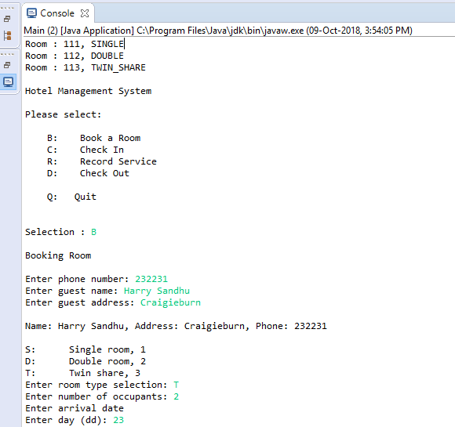

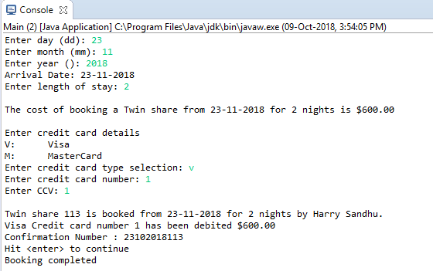

**2. CHECKIN :**

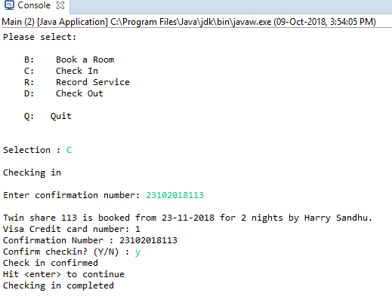

**3. USING AMENITIES:**

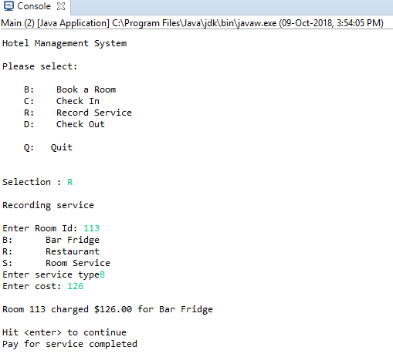

**4. CHECKOUT : The amount $126 has to be charged but it shows 0.0**

